Parent Dashboard Screen
Course Selector
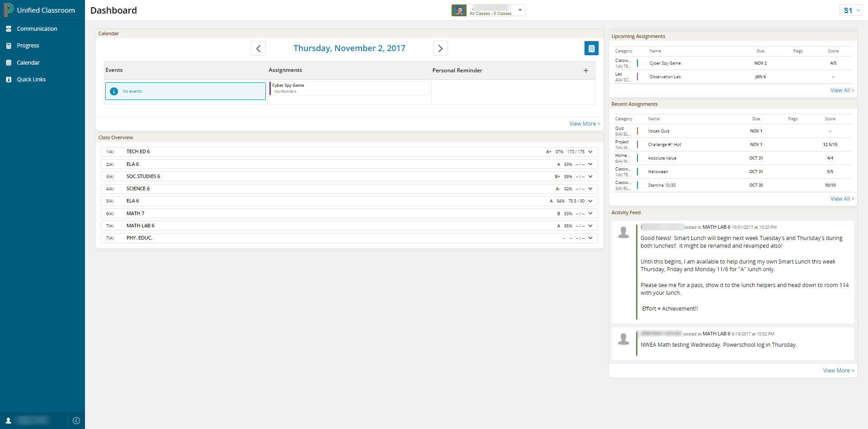
- Course Selector on top of screen.
  - Allows you to change your perspective from all classes to just a specific class or a class in a different term. Also allows you to change your student if you have multiple.
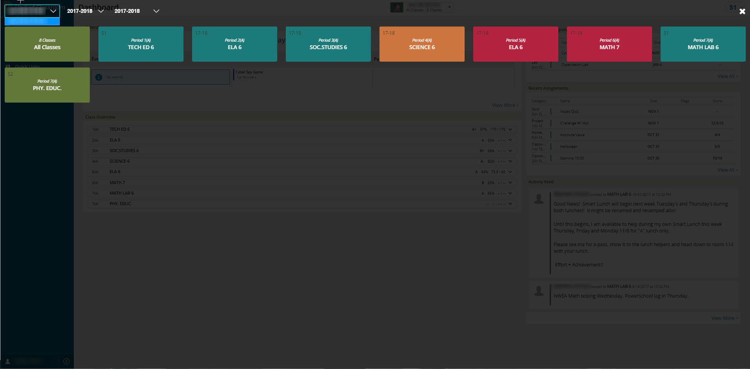
- Calendar.
  - It defaults to today’s date and different days can be selected using the arrows or the calendar picker.

  - The View More link takes you to a weekly view of the calendar that can be modified to show the Daily, Weekly, or Monthly view.
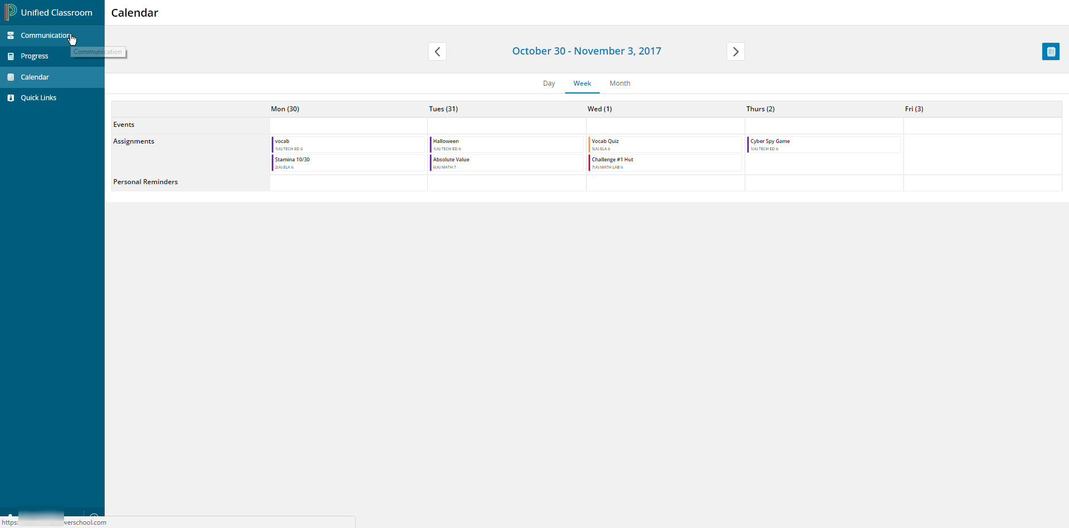
  - Allows you to see Events the teacher posts for your student’s classes.
  - Allows you to see Assignments that are due that day for your student’s classes.
  - Allows you to create (+ link) and see Personal Reminders for your students.
- Class Overview
  - Shows students full schedule and student’s current grade in each section.
- Upcoming Assignments
  - Lists upcoming / future assignments in your student’s courses.
  - View All will display all future assignments.
- Recent Assignments
  - Lists past assignments as well as students’ scores if the assignments were scored.
  - View All will display all past assignments.
- Activity feed
  - Lists all posts from the teachers to the students.
  - View All will take you to a full page screen of the Activity Feed.
- Left Navigation icons
  - Communication
    - Full page view of Activity feed.
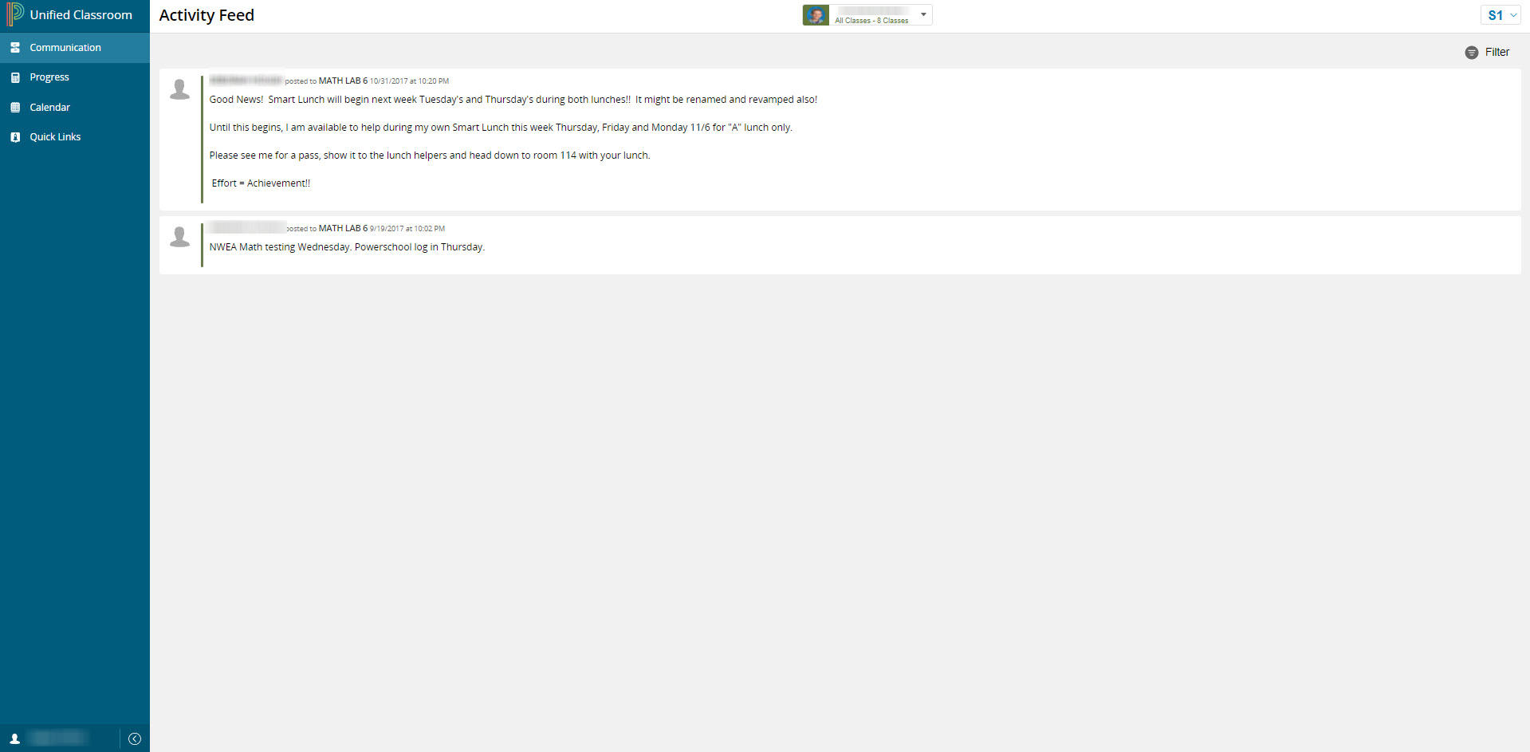

  - Progress
    - Assignments
      - Full page view of all Assignments / Activities.
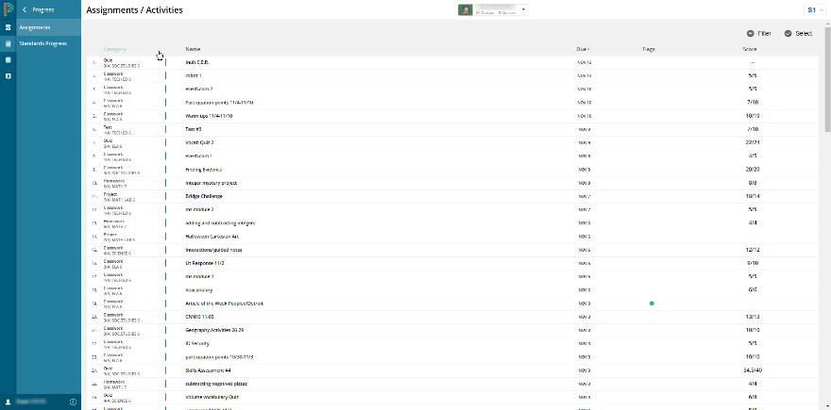
    - Standards Progress
      - Takes you back to original portal and to the Standards Progress page.
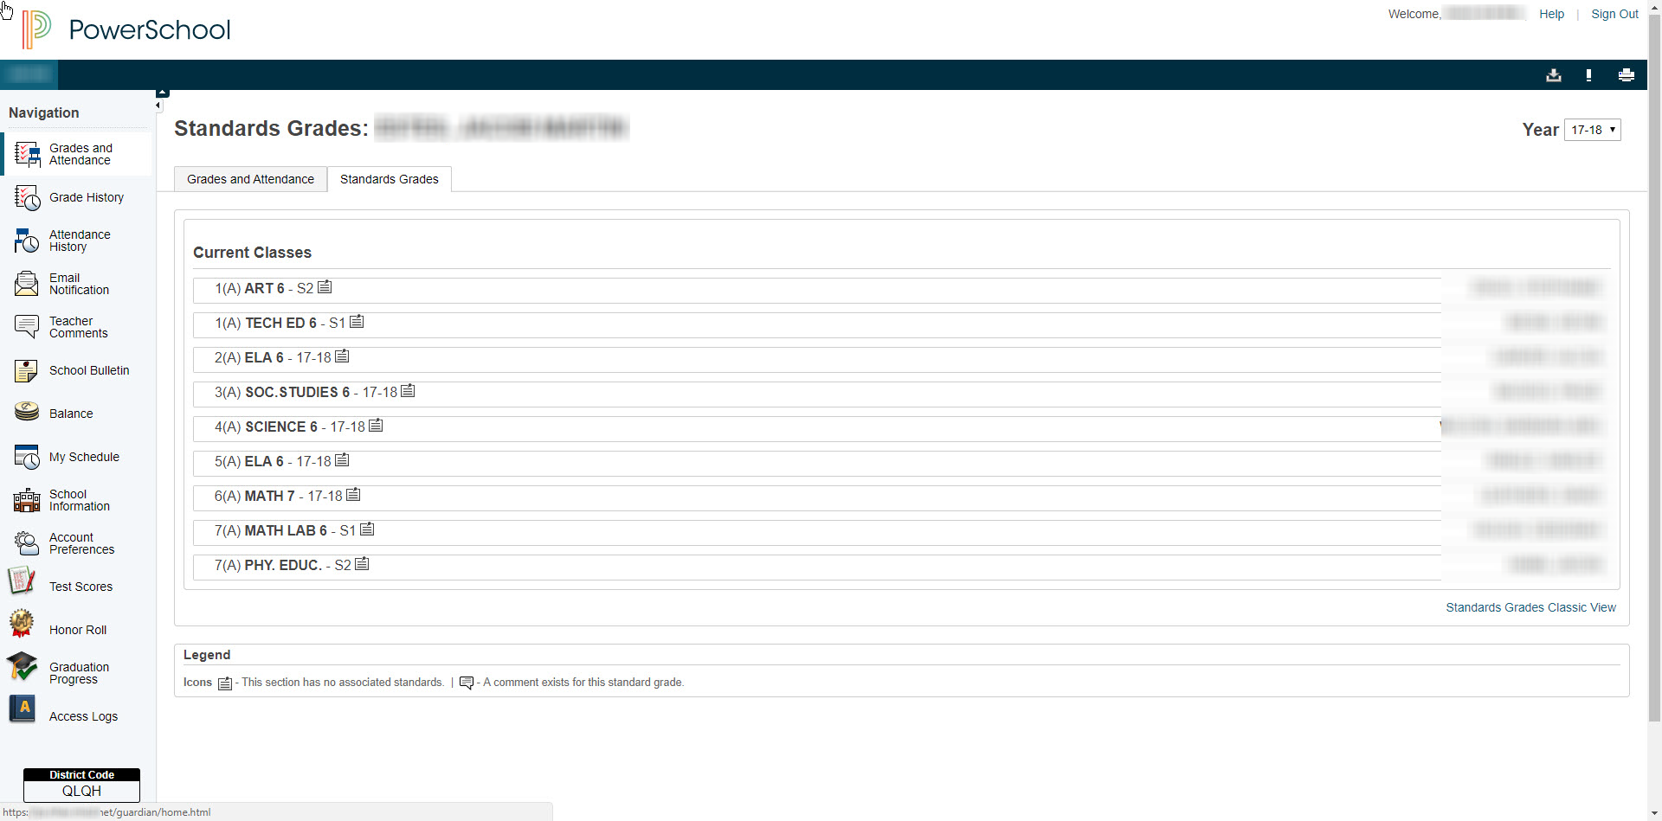
  - Calendar
    - Takes you to a weekly view of the calendar that can be modified to show the Daily, Weekly, or Monthly view.

  - Quick Links
    - Displays links to different pages from the original parent portal.
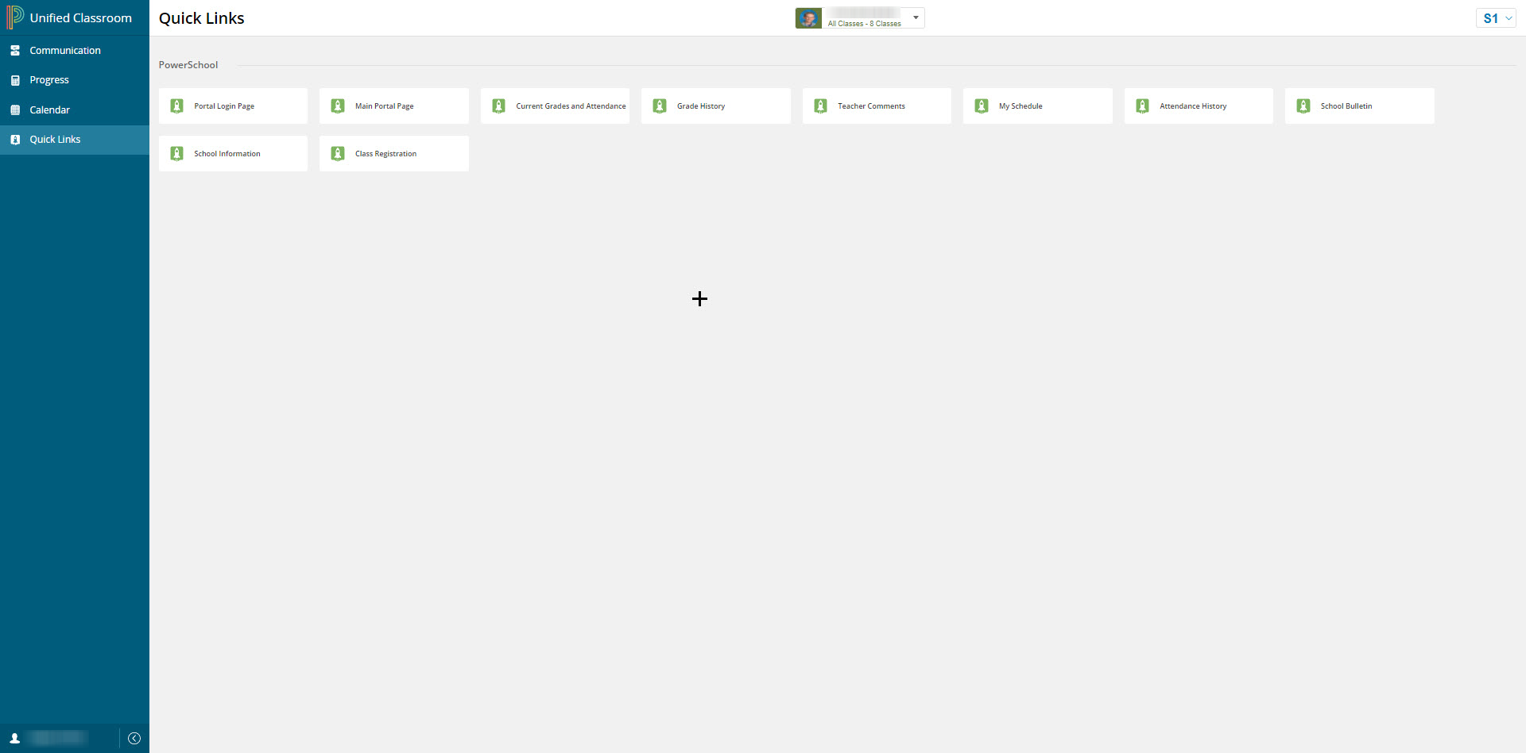
  - Click on user name on bottom left corner.
    - Profile
      - Displays account information.
      - The Edit information button allows you to change the first name and last name associated to the account, but not the username.
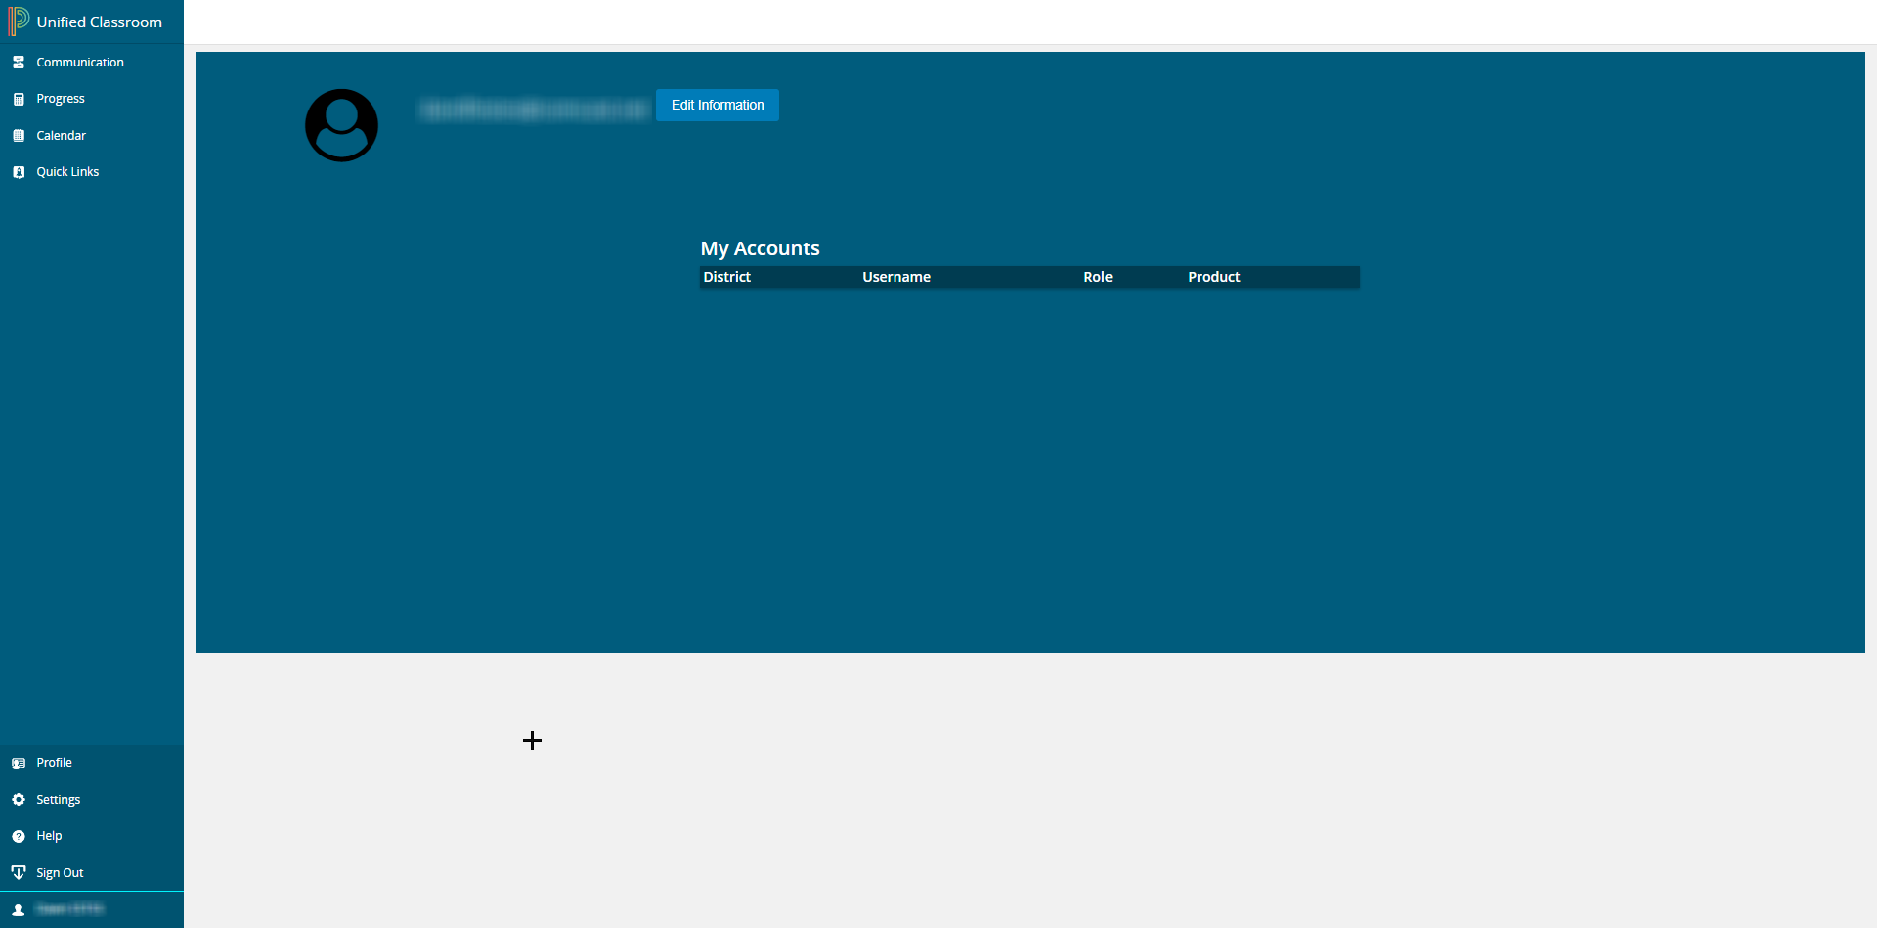
    - Settings
      - My Settings link to original parent portal settings page.
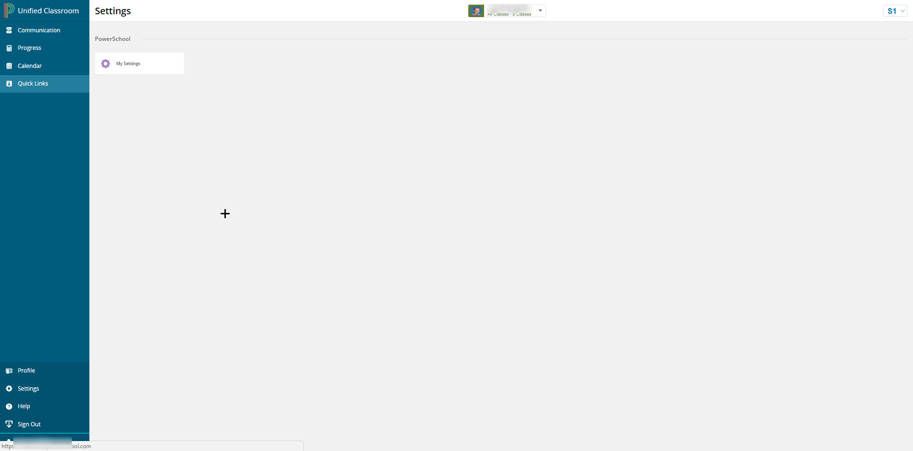

    - Help
      - Link to all help documentation for Students and Parents.
